Project Schedule

Husky Air Project

Date: 07/19/2022

Gouri Patil (Z1931431)

Manisha Reddy Bandala (Z1949511)

Megha Sudha Aluru(Z1947069)

## Network Diagram

## Task Table

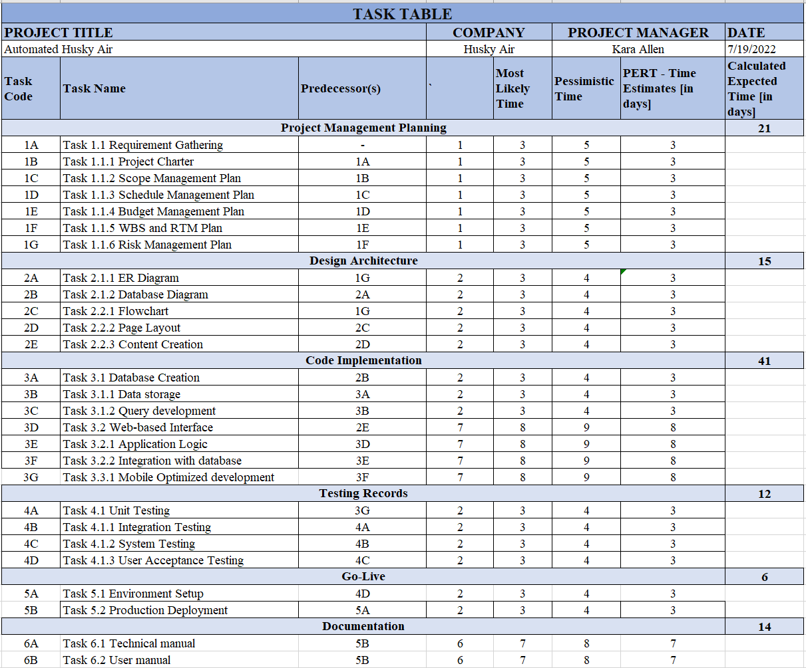

## Microsoft Project – Task List

## Microsoft Project – Gantt Chart

